LilyPad Programming activities (2)
For downloading ‘Arduino IDE’ Software: https://www.arduino.cc/en/Main/Software
Basic guidelines for all the LilyPad activities:
https://learn.sparkfun.com/tutorials/lilypad-protosnap-plus-activity-guide/introduction
Remind the first Setup for Lilypad
Whenever run the software, please check the setting;
- Run the Arduino software
- Go ‘Tools’ – ‘Board’ and find the ‘LilyPad USB Plus’
*If you are using LilyPad Mini, select ‘LilyPad LilyMini’
*If you can’t find out any of them, go to Board Mangers and search LilyPad and install the packages.
*Please check the pin number whenever you are working with example code. The pin numbers of LilyPad USB Plus and LilyMini are different.
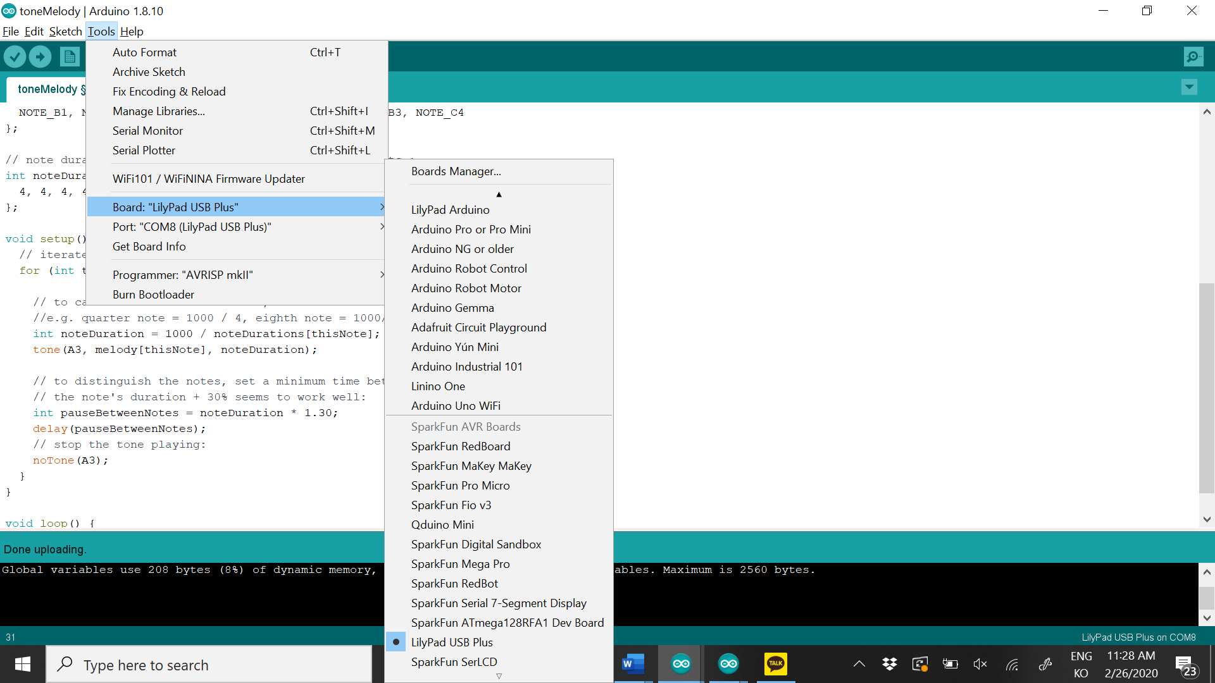
- Connect LilyPad and laptop by using the USB cable.
- Go to ‘Tools’ – ‘Port’ and check the LilyPad board. If you can’t anything there, try to reconnect the board and laptop.
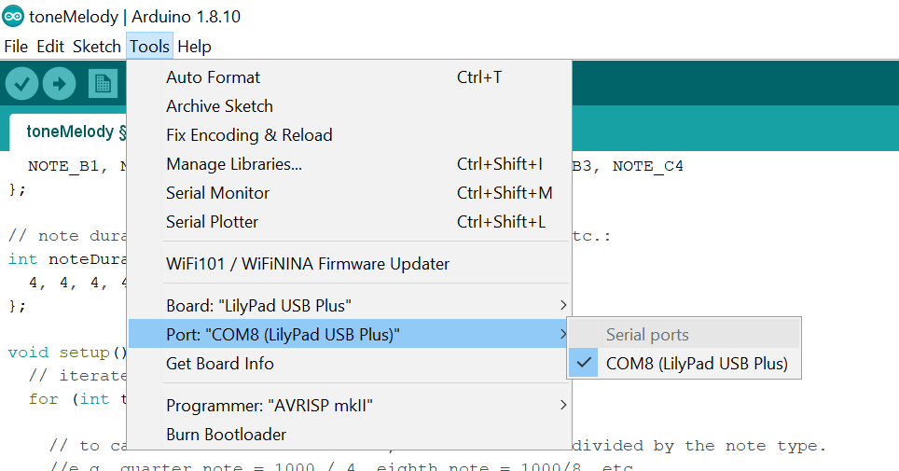

1. Buzzer – Play sound!
Download an example code from here:
https://learn.sparkfun.com/tutorials/lilypad-buzzer-hookup-guide/all

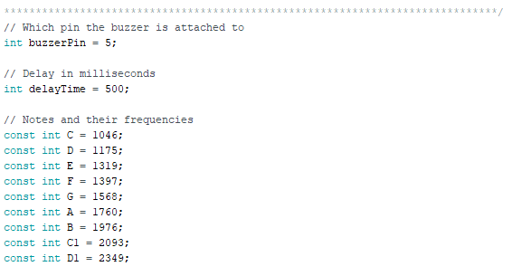
- You can see the buzzerPin value is 5, so you have to change the value to A3.
- delayTime means the delay between each note (sound). If you increase the value, the music will sound slowly.
- In the blue box, the notes that you want to use are defined. If you change the value (number), the sound will be changed as well.
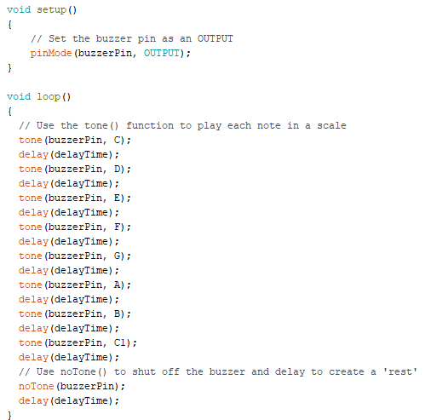
- In void setup(), the buzzer has been set as an OUTPUT device.
- In void loop(), each tone will be played in order. So, if you want to change the order, just change the values in the blue box.

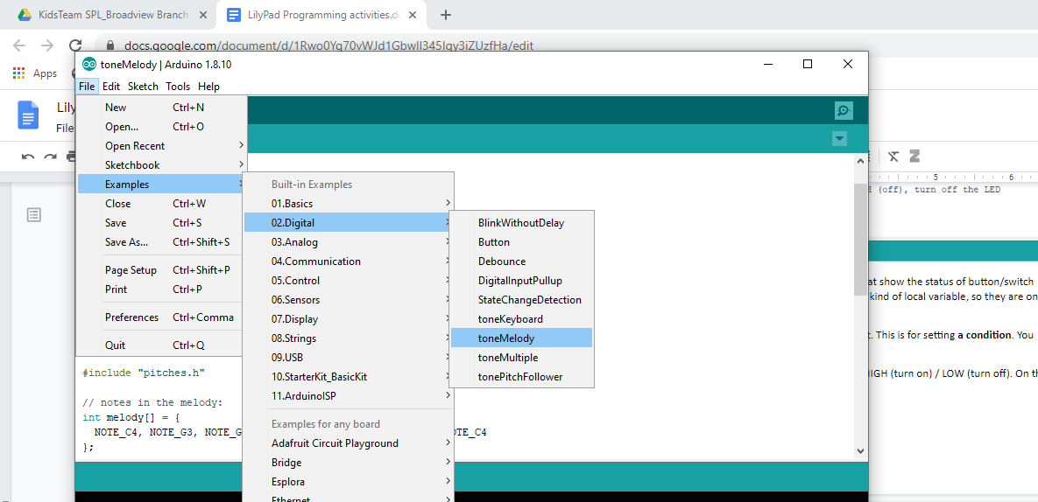
- Actually, there is another way to download example code: from Arduino software.
- Go to File – Example – Digital – toneMelody

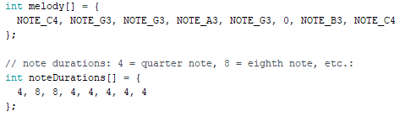
- At the top of the code, the melodies that you want to use are defined in melody[]
When you want to define multiple values in a single variable, you can use brackets next to the variable name and curly brackets as a container of the values like this picture.

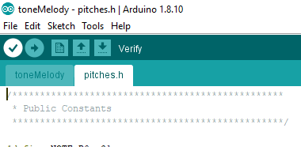
- If you want to change or add the melody, you can see the ‘pitches.h’ at the left-top side of the screen. Then, you can see the melody list.
- You can also change the delay time by changing the values in ‘noteDurations’ variable.
- In this example, you have 8 values in the melody[] variable, so you also have 8 delay times for each melody in noteDurations variable.

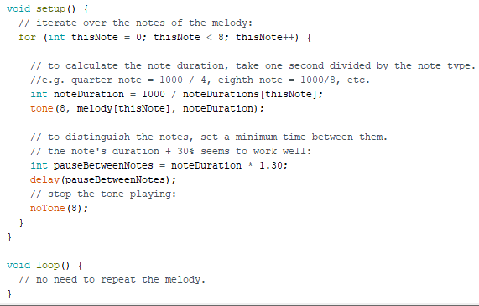

- In the red box, the new integer type variable ‘thisNote’ has been defined.
‘thisNote < 8’ means the condition.
‘thisNote++’ means add 1 to ‘thisNote’ if the condition is true.
- In the blue box, this is code for playing sound.

- Let’s see how it works. The initial value of ‘thisNote’ is 0, so melody[0] (the first value of melody[] variable) will sound as defined in the blue box.
- However, ‘thisNote’ is less than 8, so the condition is TRUE. So, the value of ‘thisNote’ will become 1.
- Now, ‘thisNote’ is 1. So, melody[1] will sound like the first step. However, ‘thisNote’ is still less than 8, so ‘thisNote’ will become 2.
- It will repeat 8 times because you have 8 melodies in ‘melody’ variable. Therefore, if you want to add/subtract the melodies, you have to change the values in the code as well. Try to figure out which value you should change.

3. Control the sound!
You maybe control the sound. For example, turn on/off the sound by using switches or buttons. Or, you can even use light sensor.

Do you remember how to use switch, button, and light sensor?
- Example codes for switches/buttons
https://learn.sparkfun.com/tutorials/lilypad-protosnap-plus-activity-guide/6-buttons-and-switches
- Example code for light sensor
https://learn.sparkfun.com/tutorials/lilypad-protosnap-plus-activity-guide/7-sensing-light
Or, I recommend you practice our previous document more!

Download the example code from here:
https://learn.sparkfun.com/tutorials/lilypad-buzzer-hookup-guide/all (Second example code)

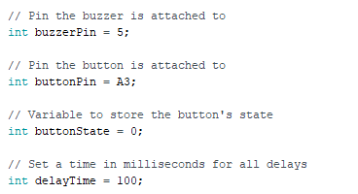

- In this example, we are going to use buttons for playing a buzzer.
- The buttonPin and buttonState variables are defined.
You have to change the ‘buttonPin’ value to ‘A4’ because we are using the different main circuit from the example.

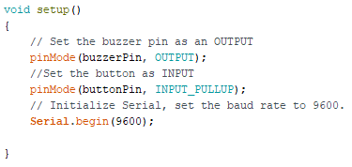

- pinMode(buttonPin, INPUT_PULLUP) is also defined in void setip().
(Review: button/switches use ‘INPUT_PULLUP’, not ‘OUTPUT’)

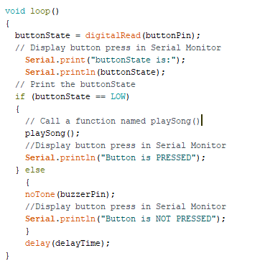
- In the void loop(), the function for making a sound by using a button is defined.
- The value of ‘buttonState’ will be changed as you push the button or not through digitalRead(buttonPin) code. If you push the button, the buttonState value will be ‘LOW’.
- So, according to the conditional code (if), when the value of buttonState is ‘LOW’, it will run the playSong() function.
- ‘playSong()’ function is defined at the bottom of the code like the picture below.

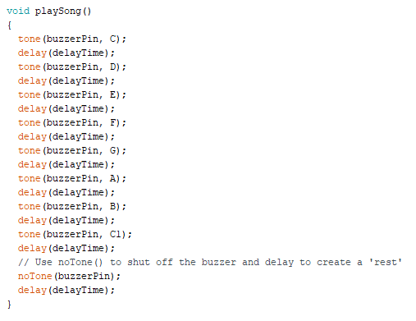

- Maybe you can replace playSong() function with what we used before such as ‘for’ function.

Are you confident with using buzzer now?
Can you use switch or light sensor with buzzer like button example?

