LilyPad Programming activities
For downloading ‘Arduino IDE’ Software: https://www.arduino.cc/en/Main/Software
Basic guidelines for all the LilyPad activities:
https://learn.sparkfun.com/tutorials/lilypad-protosnap-plus-activity-guide/introduction
First Setup for Lilypad
- Run the Arduino software
- Go ‘Tools’ – ‘Board’ and find the ‘LilyPad USB Plus’
*If you are using LilyPad Mini, select ‘LilyPad LilyMini’
*If you can’t find out any of them, go to Board Mangers and search LilyPad and install the packages.
*Please check the pin number whenever you are working with example code. The pin numbers of LilyPad USB Plus and LilyMini are different.
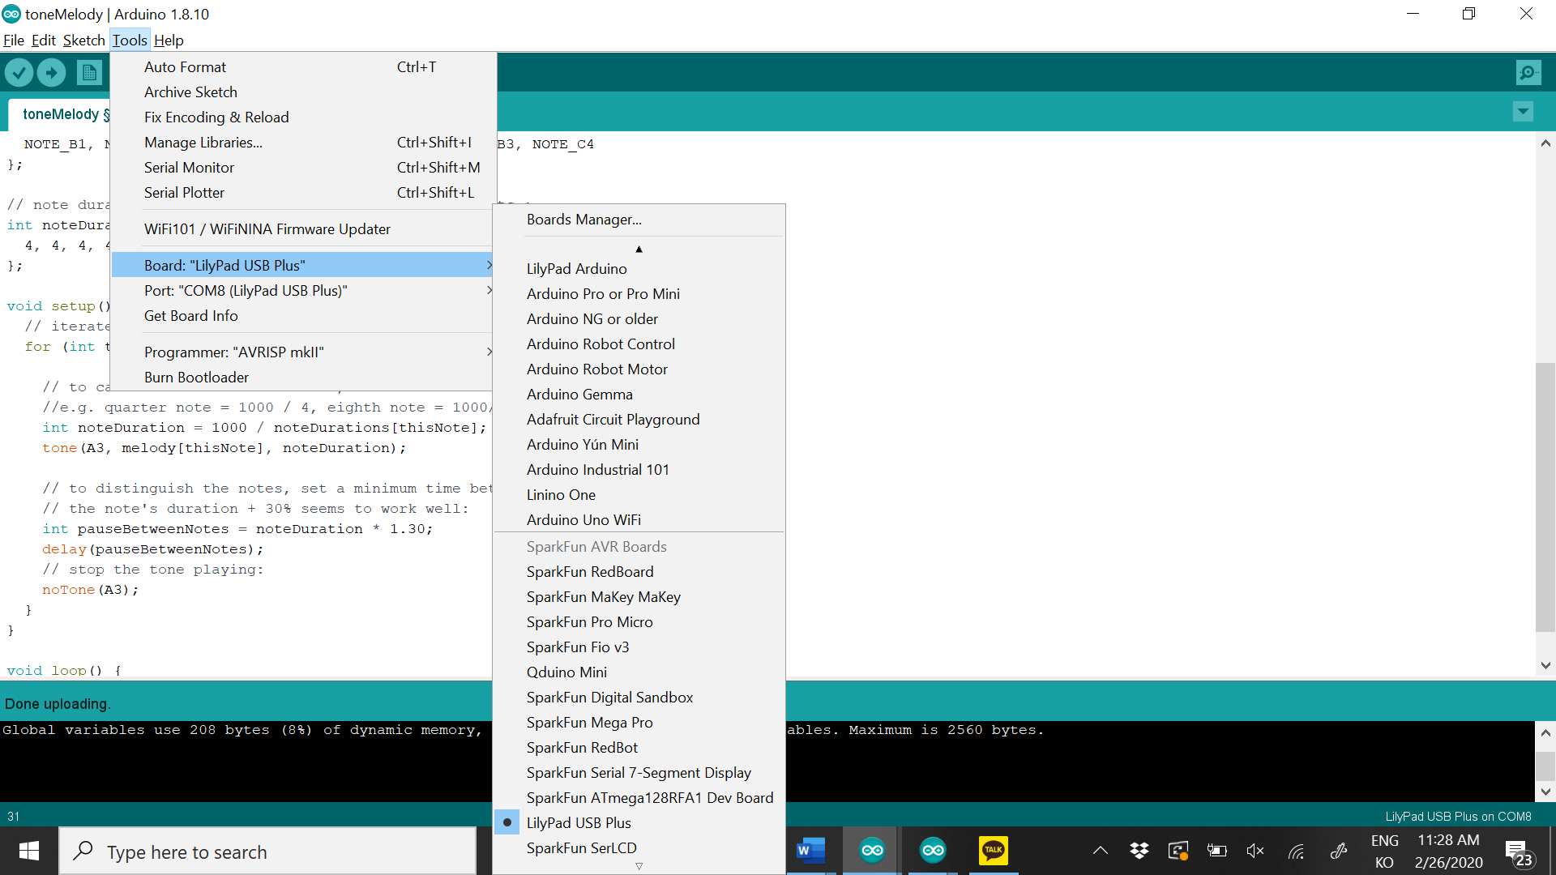
- Connect LilyPad and laptop by using the USB cable.
- Go to ‘Tools’ – ‘Port’ and check the LilyPad board. If you can’t anything there, try to reconnect the board and laptop.
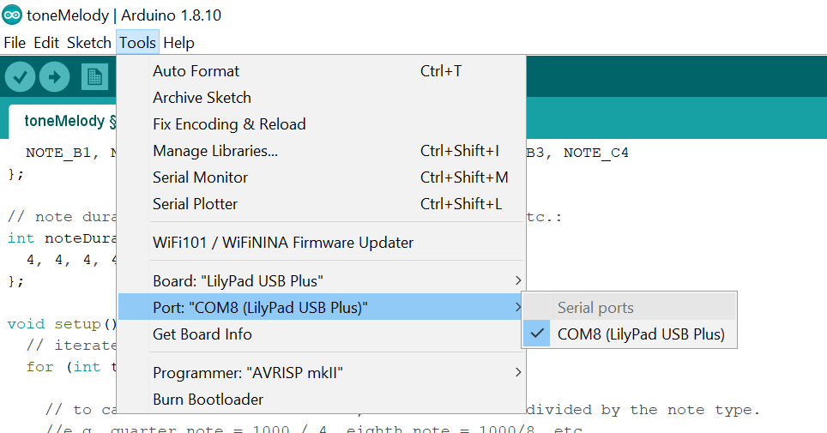
- Play with LED lights
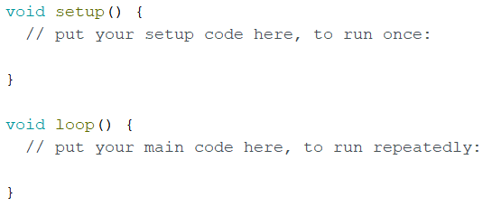
If you run the Arduino IDE software, you can see these codes. They mean two important parts.
Section for basic setting
Section for main codes.
The setting you defined at void setup() will be applied here.
So, keep it in mind before moving on to the activity.

1.1 Make LED lights blink
Start with example code from here:
https://learn.sparkfun.com/tutorials/lilypad-protosnap-plus-activity-guide/1-blinking-leds
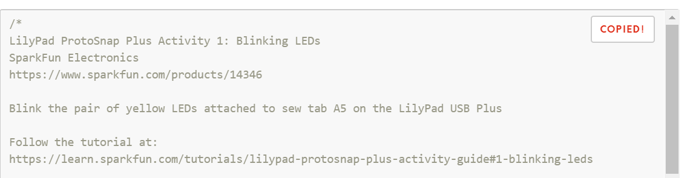
- Copy the codes here and paste on your Arduino IDE. (Before pasting it, you should delete all the default code on your Arduino IDE.)
- Then, Click the ‘Verify’ button at the left-top side of the software and see if your codes are compiled successfully.
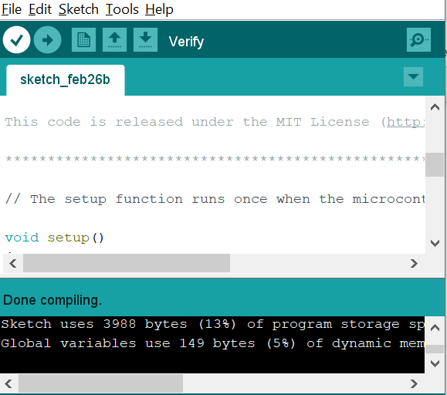
- If compiled successfully, click the ‘Upload’ next to the ‘Verify’ button.
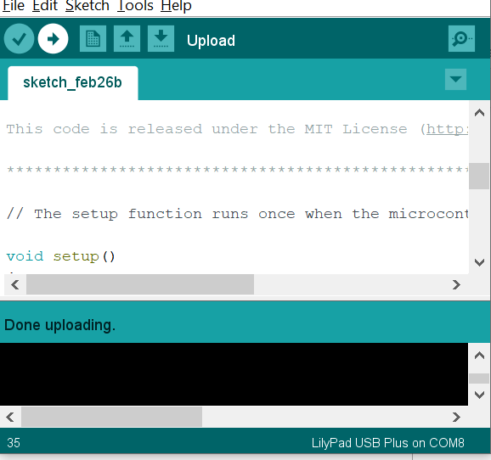
- After uploading, see what happens on your LilyPad board.
- If you see the Yellow LED lights at the ‘A5’, it works very well.
- For further explanation, ‘HIGH’ means turn on and ‘LOW’ means turn off.
The values in delay(), 1 means 1 milliseconds, so if you want to blink for a second, you should input
1000.

1.2 Customizing
- You can make other LED lights blink. You can also make many LED lights blink at the same time with different pause time. It is not difficult. Just add, copy, and paste the codes. Here is a simple customizing example – (File: EX_LED_3Lights)
- In this example, 3 LED lights will blink in a different pause time.
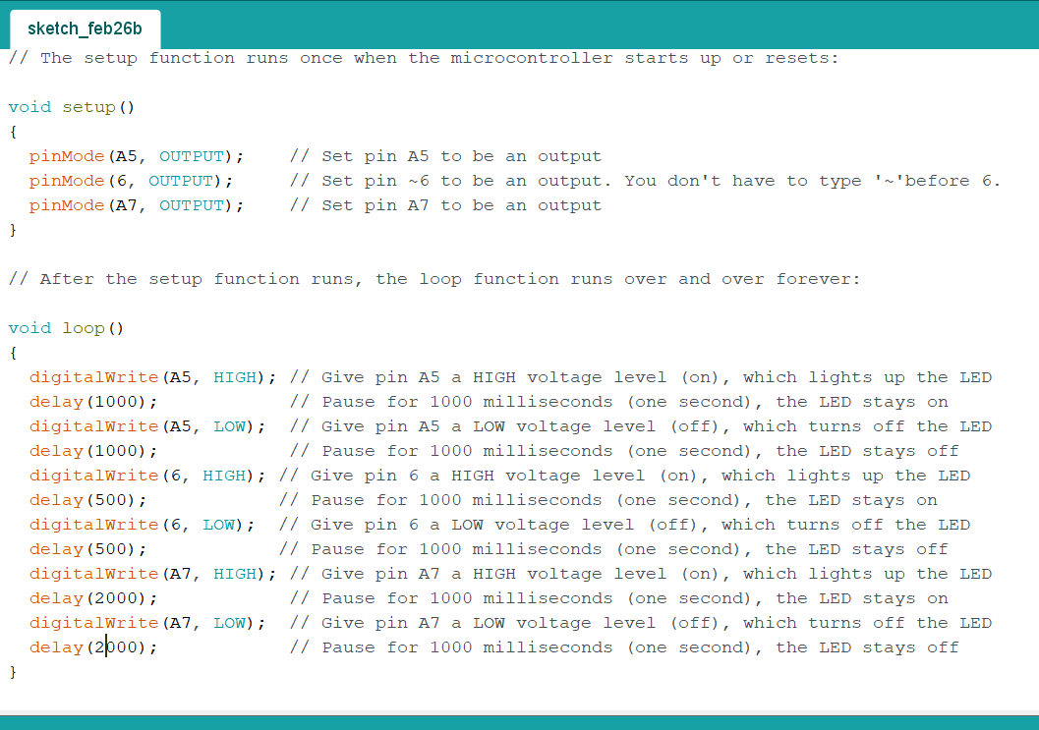
- In void setup(), pin ~6 and pin A7 have been added.
- In void loop(), 8 lines have been added for making pin~6 and pin A7 blink.
- You can see the values in ‘delay()’ are different.
- Then, try to make your own! Maybe you can make some patterns by making them turn on at the same time. Remember. You don’t need any other new codes for this activity. All you need is just copying, pasting, and changing the values.

1.3 Control the LED lights
You might want to control the LED lights. We are going to use three LilyPad parts to control them; Switches, Buttons, and Light sensor.
1) Switches / Buttons
They are operated by a similar way. For this activity, download a sample code from here:
https://learn.sparkfun.com/tutorials/lilypad-protosnap-plus-activity-guide/6-buttons-and-switches
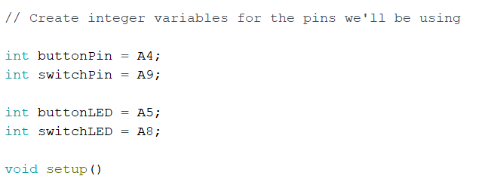
In this code, 4 variables have been declared over the void setup(). They are a kind of global variable that can be used anywhere in the code. Usually, their type is integer (int).

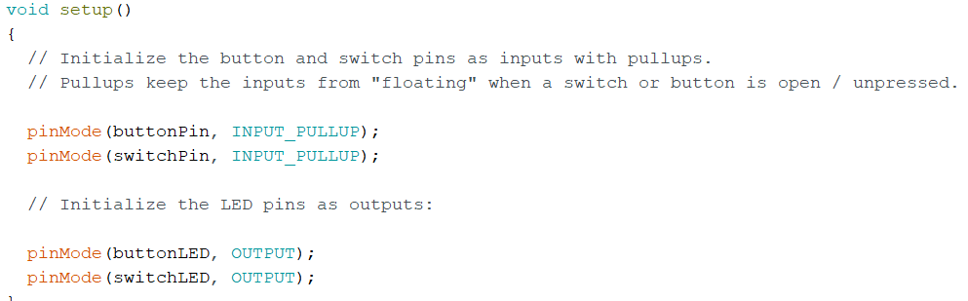
In void setup(), pinMode functions have been set up. INPUT_PULLUP is a built-in function for switches or buttons – Pressed/Unpressed.
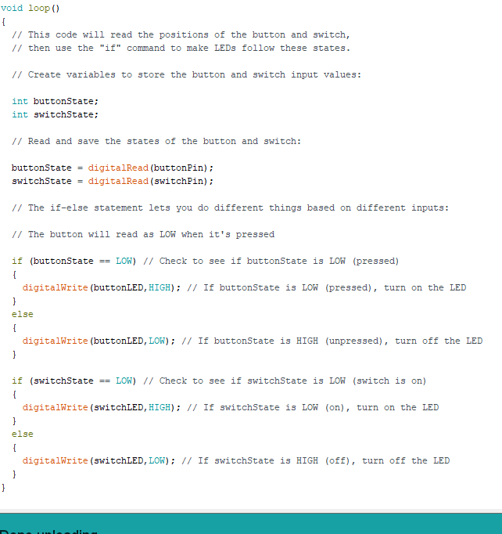
- Let’s see the code under the void loop(). At first, two variables that show the status of button/switch are declared – buttonState and switchState. These variables are a kind of local variable, so they are only valid in the void loop().
- The other thing that you can see in this code is IF/ELSE statement. This is for setting a condition. You can make LED lights work in a specific condition.
- Something tricky in this code is that HIGH/LOW - For LED lights, HIGH (turn on) / LOW (turn off). On the other hand, for switch/button HIGH (pressed) / LOW (unpressed).
- Then, verify and upload this code and let’s see what happens. Can you see LED lights turn on/off when you are pressing the button or turn on the switch?
- Let’s practice more. 1) How can we make two or more LED lights turn on at the same time? 2) How can we make them opposite way – can we make LED lights turn off when you press button or turn off the switch? What code do we have to add and where should we put them? Here is the example I made.
(File: SwitchButton_EXP)
###Maybe we can stop here if we don’t have enough time. If so, just move on to the design activity.
2) Light Sensor
LilyPad can also detect the light with Light sensor. Download the sample code from here:
https://learn.sparkfun.com/tutorials/lilypad-protosnap-plus-activity-guide/7-sensing-light
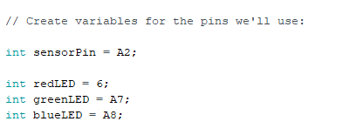
- First, declare 4 variables – sensorPin and three LED lights. (You can see the color of each LED light part from the back side of it.)
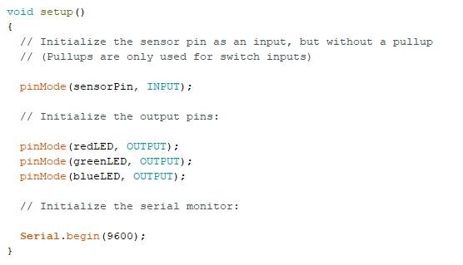
- In void setup(), declaring light sensor pin as an INPUT part and three LED lights as an OUTPUT part.
- At this point, you don’t have to think about ‘Serial.begin ‘.
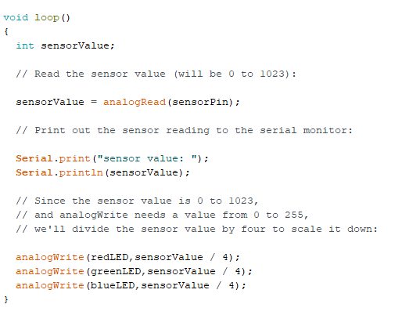
- In void loop(), sensorValue has been declared. This is also a kind of local variable that is only be valid in void loop().
- analogRead() is a function for saving a light level that is detected by a light sensor in a numeric (integer) value. The light level that the light sensor can detect is 0 to 1023, so the maximum value of ‘sensorValue’ is 0 to 1023.
- You don’t have to consider ‘Serial.print’ and ‘Serial.printIn’ here.
- analogWrite() is a function for turning on the light in a specific light level.
The format of this function in this code is analogWrite(A, B) –
A means the light that you wan to turn on.
B means the light level. The maximum light level of LED light is 255 and the maximum value of
sensorValue is 1023, so the value in B has been divided by 4.
- If you understood this code, verify and upload it. Can you see what is happening?
- Maybe you want to make it opposite way: turn on the lights when it darks. Here is the example code for it: (File: Sensor_Opposite)

Designing Activity: Help me!
At this point, you practiced how to make LED lights turn on/off and control them by using a button, switch and light sensor. Now, imagine you are in a trouble where you need a light. For example, stuck in a mountain at night. Maybe we already talked about it during the circle time! How can you use LED lights for that situation? Can you apply what we learned to this situation? Please draw and sketch your idea on a big paper.

